SIMATS ENGINEERING (SAVEETHA SCHOOL OF ENGINEERING)
Department of Computer Science and Engineering

ASSESSMENT TOOL 2 – Concept Mapping

Course Code: | CSA0309 | Course Title: |  | Data Structures
CO Assessed: | CO1 – Imitation (BL3, BL4) | Assessment: |  | Assessment Tool 2 – Concept Mapping
Weightage: | 35% of CIA | Total Marks: |  | 100
CO1 Statement: | Apply suitable data structures and ADTs for efficient problem solving by analyzing time and space complexity.
Student Name: | K. Pujitha |  | Reg. No.: | 192524149
Section / Batch: | 2nd year AI&DS |  | Date: | 08/07/2026
Code of Conduct
I K. Pujitha (192524149) certify that this submission is my original work and that I have adhered to the guidelines specified for this assessment. I understand that any violation of academic integrity rules will result in disciplinary action.
Signature of the Student: K. Pujitha
Instructions
- This test contains 5 Concept mapping questions. Total: 100 Marks.
- When a student answer using a concept map, in evaluation the answer should be with following four requirements: Understanding of concepts, Connections between ideas, Logical structure, Clarity of representation.
- No negative marking. Unanswered questions carry zero marks.

Section / Topic | Focus | Q Nos | Marks
Linked data structure | Basic data structure | 1 | 20
Primitive and Non-Primitive Data Structure - Linear and Non-Linear Data Structure | Classifications of Linear data structure | 2 | 20
Search Data Structure | Linear Search and Binary Search | 3 | 20
Recursion, Performance analysis | Recursion | 4 | 20
Tree Data Structures | Classifications of Tree data structure | 5 | 20
GRAND TOTAL: |  | 100 Marks

Annexure A – Concept Mapping

- A smart city traffic management system handles data related to vehicle movement, road networks, and signal control. Construct a concept map connecting Primitive Data Structures
→ Non-Primitive Data Structures → Linear → Non-Linear Structures. Include examples such as arrays, linked lists, trees, and graphs, and illustrate their applications in traffic management. Explain the relationships between these structures and justify their classification based on functionality and efficiency. (20 Marks)
- A smart healthcare system processes large volumes of patient data such as temperature readings, medical history, and diagnostic details. Construct a concept map linking the progression from Data → Data Object → Data Structure → Abstract Data Type (ADT) → Implementation in C. Identify relevant sub-concepts such as structures, pointers, and operations, and establish meaningful relationships among them. Organize the concept map hierarchically and justify how each level contributes to efficient data organization, processing, and improved system performance. (20 Marks)
- E-commerce platform manages product storage, searching, and recommendation systems.
Construct a concept map linking Linear Data Structures → Sequential Access → Limitations
→ Non-Linear Data Structures → Hierarchical/Network Relationships → Applications. Analyze the differences between linear and non-linear structures and demonstrate how each supports specific components of the system. Justify which structure is more efficient for handling complex applications. (20 Marks)
- A video streaming application must balance speed and memory usage. Construct a concept map connecting Time Complexity → Space Complexity → Tradeoff → Algorithm Design → Performance Optimization. Analyze how improving one factor affects the other and justify the optimal balance. (20 Marks)
- A digital archive stores millions of documents. Construct a concept map linking Searching → Linear Search → Binary Search → Sorted Data → Time Complexity → Performance. Analyze the impact of data organization on search efficiency and justify the best technique.(20 Marks)
Rubrics for Calculation
Criteria | Weightage | Level 4 – Exemplary | Level 3 – Proficient | Level 2 – Developing | Level 1 – Beginning
Understandi ng of Problem Context | 20 | Clearly understands the problem and accurately identifies all requirements | Good understanding with minor gaps | Basic understanding; some requirements unclear | Poor understanding or misinterpretation of the problem
Application of  Concepts | 30 | Accurately applies appropriate concepts to solve complex problems | Applies relevant concepts correctly with minor errors | Applies basic concepts with limited accuracy | Fails to apply appropriate concepts
Problem-Solving Approach | 20 | Logical, well-structured, and efficient approach | Mostly logical approach with minor gaps | Basic approach with some inconsistencies | Illogical or unclear approach
Accuracy of Solution | 20 | Completely correct solution with proper justification | Mostly correct with minor errors | Partially correct solution | Incorrect or incomplete solution
Clarity | 10 | Clear, well-organized, and  properly explained solution | Understandable with minor clarity issues | Limited clarity and explanation | Poorly presented and difficult to understand

Faculty In-charge | Course Coordinator | Program Director
Signature: | Signature: | Signature:
Date: | Date: | Date:

1)

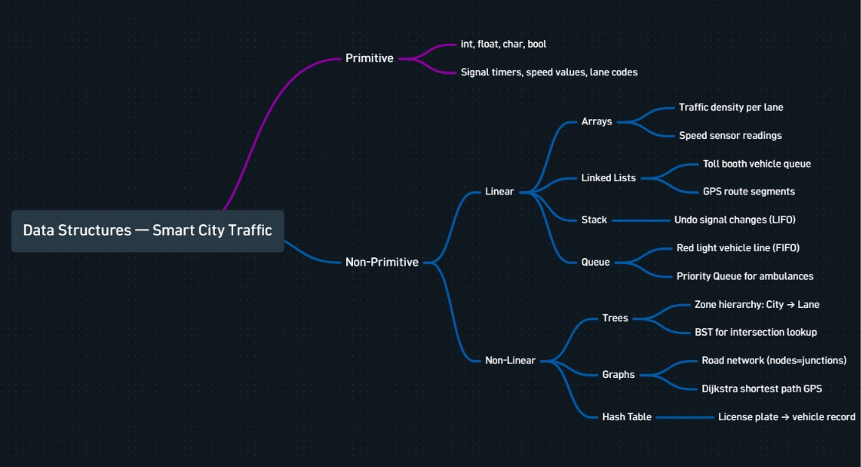
2)

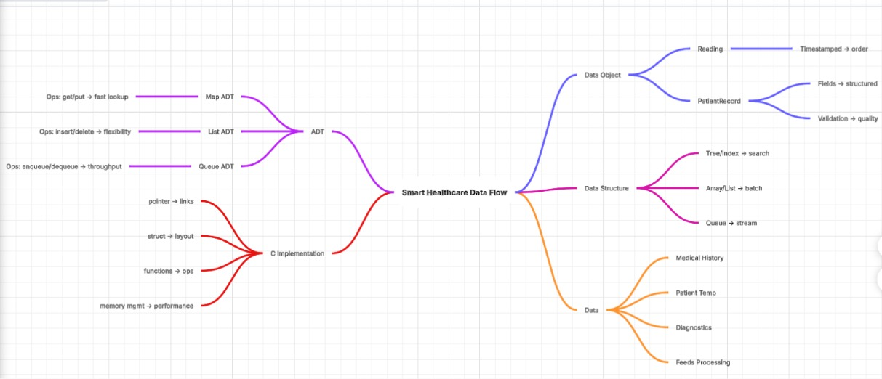

3)

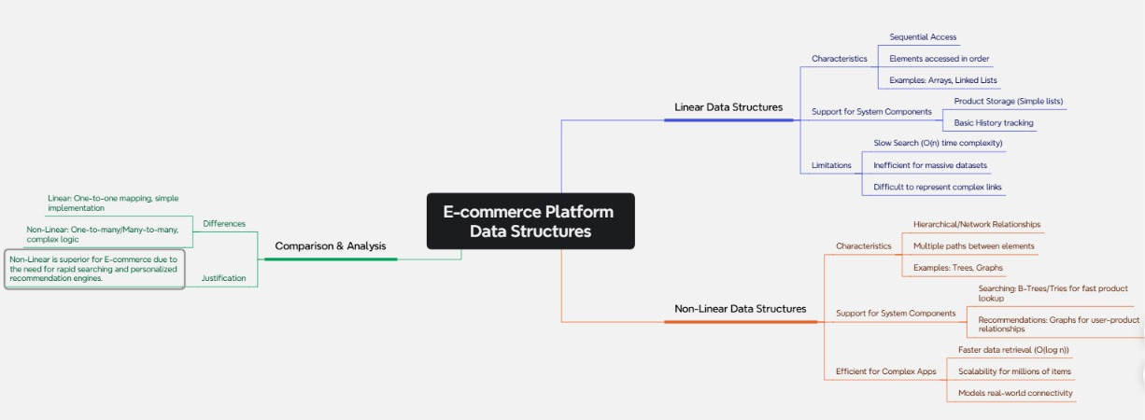

4)

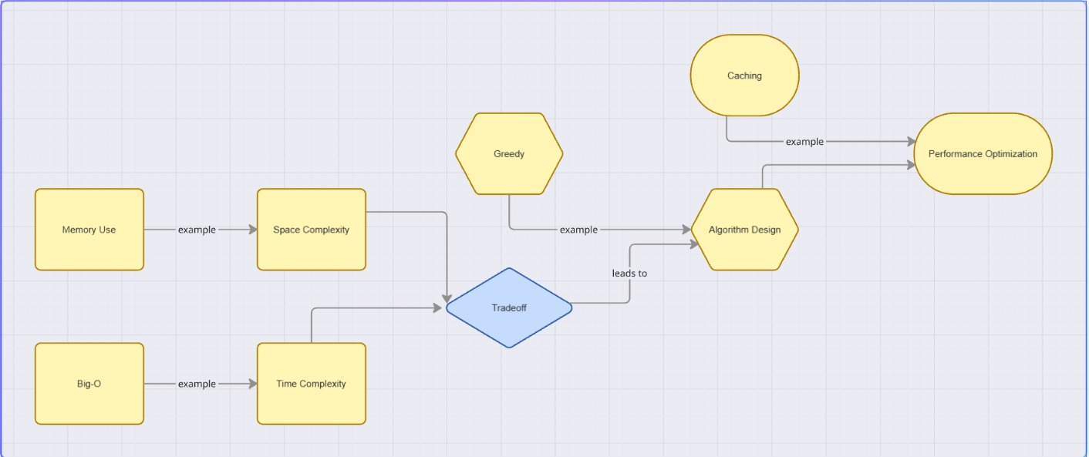

5)

